# 

# Running the NORTRIP model in the MATLAB environment

The following document briefly explains how to install and run the Matlab version of NORTRIP (NORTRIP_model_public_v3_2)

# Setting up the NORTRIP model MATLAB scripts

1. Copy the zip file ‘NORTRIP_model_public_v3_2.zip’ to the directory you want to place it in and extract. Within the ‘NORTRIP_model_public_v3_2’ are a number of directories that are set up for the model calculations
2. This document describing the model are provided in the ‘documentation’ directory
3. Open the ‘scripts’ directory. Here are all the Matlab scripts for running Matlab. The control script for running the model is called ‘NORTRIP_control_v3’. Open this in the Matlab environment
4. At the start of the script is the code given below. **You must set the ‘root_path’ to where you have placed the NORTRIP folder**. In this case ‘C:\NORTRIP\NORTRIP_model_public_v3_2\’. (A directory delimiter ‘dir_del’ option has also been put in to differentiate between Linux and Windows).

%--------------------------------------------------------------------------

%Set these to specify root path, model run info path and directory delimiter

%--------------------------------------------------------------------------

%Directory delimiter which is different for windows or linux

dir_del='\'; %Windows

%dir_del='/'; %Linux

%Set the default user path

%root_path='C:\NORTRIP\NORTRIP_model_public_v3_2\';

root_path=['C:',dir_del,'NORTRIP',dir_del,'NORTRIP_model_public_v3_2',dir_del];

userpath(root_path);

cd(root_path);

%Set model run file name that contains filenames and paths

path_modelrun_data=['model_paths',dir_del];

filename_modelrun_data='model_paths_and_files.xlsx';

%--------------------------------------------------------------------------

1. Setting this ‘root_path’ will allow the model to read the file ‘\model_paths\model_paths_and_files.xlsx’ which contains all the path and file information for NORTRIP. Within this file the paths are currently set up to work for the ‘root_path’ ‘C:\NORTRIP\NORTRIP_model_public_v3_2\’. **Go into this excel sheet and change all the paths to where your data now is**.
2. If Linux (or fortran) is used then there are also text versions of all the excel sheets. These are contained in sub folders called ‘text’ within the different directories. To choose to read the text files instead then set the parameter ‘read_inputs_from_text=1’. The script will automatically adjust the ‘.xlxs’ to ‘.txt’ and will look for the files within the ‘text’ subfolders.

%--------------------------------------------------------------------------

%Set whether to read parameters and input from text files instead of excel

%Reading from text files is quicker. If selected then will automatically

%replace '.xlsx' with '.txt' on the file names

%--------------------------------------------------------------------------

read_inputs_from_text=0;

%Set the individual reading flags based on read_inputs_from_text

%Provides flexibility in what is read from text or from excel

if read_inputs_from_text,

read_inputdata_as_text=1;

read_infofile_as_text=1;

read_parameters_as_text=1;

else

read_inputdata_as_text=0;

read_infofile_as_text=0;

read_parameters_as_text=0;

end

%--------------------------------------------------------------------------

# Running the NORTRIP model from MATLAB scripts

1. To run NORTRIP using the example input data provided then simply press F5 or select ‘run’ for the control script. Matlab will probably ask you if you want to add this script to the paths the first time you run it. Click on ‘Add paths’. You can also permanently set up this path in Matlab using the ‘Home->Set paths’ menu option in Matlab. Browse for the ‘scripts’ directory then choose ‘Add with subfolders’ to add this permanently.
2. Once started the following text should appear in the command window. Before looping through the dates. Note that reading the excel input files with Matlab is a slow process and usually takes 30 – 60 seconds for a whole year of data. Reading from text files is significantly quicker.

Starting NORTRIP_model_public_v3_2

Reading info file and setting paths from excel

Setting constants

Reading parameters from excel

Reading input data from excel

Redistributing activity input data

Calculating radiation and running mean temperature

Starting time loop

1. All being well then the model will finish with some summary statistics in the command window. These are tab separated and can be pasted directly into an excel sheet for making figures etc.
2. In addition to the text a number of plots will appear. Each shows a different aspect of the model calculations. A summary plot, for the default set up and input data file should look like the following figure. The default is to show daily mean concentrations but other temporal aggregations can also be shown, see section 6.

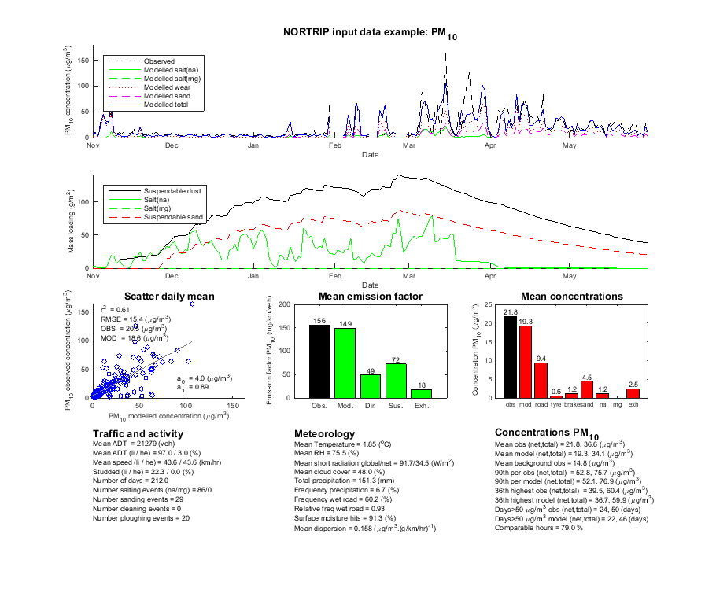

.

# Some other points concerning the control script

1. NORTRIP has also been developed as a road weather forecast model. There is an option in the control script ‘forecast_hour’ that controls if it is used in this mode for road surface temperature. This should be set to 0 so that no forecast is made.
2. There is an option ’use_fortran_flag’. This option will run the compiled fortran version of NORTRIP (contained in the ‘fortran’ folder), calling this from the Matlab script. This option will also automatically generate the text files required for fortran (it does not read excel). You can use this but generally it is not necessary.

# Model run path and file names

All the paths and filenames used by NORTRIP are contained in the file ‘model_paths/model_paths_and_files.xlsx’. You can change these if you have put data in other directories. A script called ‘set_road_dust_inputdata_files_v1’ is also often used to change these paths and names after they have been read in. This can be more convenient than changing names in the excel sheet.

# Input data files

An example input data file is provided (‘/input_data/ NORTRIP_input_data_example.xlsx’). The code looks for the key words in the files and reads the rows and columns appropriately. An explanation concerning the contents of these files is given in the sheet ‘Explanation’. In the sheet ‘Metadata’ you can also control the running and saving dates of the file, amongst others. This is also described in the sheet.

# Model parameter and control file

The file ‘/model_parameters/Road_dust_parameter_table_v5.xlsx’ very much controls the running of NORTRIP. It contains three sheets

1. ‘Parameters’. This sheet contains all the model physical parameters. In general you do not change these though there can be occasions when this is necessary. The current model parameters have been successfully applied to many roads so I do not recommend tuning activities to individual datasets. If you do change these parameters then you are in essence ‘changing the model’.
2. ‘Flags’. These are controls for some of the physical processes in the model but also for output. For example, change the ‘plot_type_flag’ to generate different temporal aggregations of the results. If the ‘save_type_flag’ is set to one of the save data types then the data will be saved in this aggregation.
3. ‘Activities’. These are the rules controlling the automatic road maintenance activities. If these are used (see ‘Flags’ sheet) then ‘suitable parameters can be chosen here.

# Common problems

The most common problems are with the input data or path or file naming. Though the model should run on the default dataset. When you make your own input data set then the following tips are given.

1. The number of rows for the ‘traffic’, ‘meteorology’ and ‘airquality’ sheets must be the same. The model only reads the dates in the ‘traffic’ sheets but it is wise to have these dates in all three sheets. Sometimes, when cutting and pasting into excel sheets, extra rows can come in. Be aware of this.
2. The ‘activity’ sheet does not need to be continuous, as the other input data sheets do. The model sorts these dates appropriately.
3. You can add additional columns to all the input data sheets as long as they do not contain the same keywords then the model will not use them. Do not change the key words in the columns. If the model finds the key words twice it will use the first. Note that reading of the excel sheets through Matlab is not fast. If additional columns are included then Matlab still reads these columns, though does not use them, so it will take more time.
4. There are various checks in the model concerning missing data (specified value in the ‘metadata sheet’). For example if there is missing traffic data then the model will fill this with average daily cycle, based on the good data. Other data such as meteorology it will fill in with the last good value. Best to avoid the’ no data’ flag and fill in yourself properly in the excel sheets.
5. Always check the hourly input data visually in the output plots to make sure there are no strange data being input to the model.

# Questions

There will always be questions. Contact me directly by mail ([bruce.denby@met.no](mailto:bruce.denby@met.no)). I can usually fix problems quickly. At the moment there are not a large number of users so feel free to contact me.

# Documentation

The model physical and numerical description is provided in these two open source articles. Some, but not significant, changes have been made since these publications.

Denby, B.R., Sundvor, I., Johansson, C., Pirjola, L., Ketzel, M., Norman, M., Kupiainen, K. , Gustafsson, M., Blomqvist, G. and Omstedt, G., 2013. A coupled road dust and surface moisture model to predict non-exhaust road traffic induced particle emissions (NORTRIP). Part 1: road dust loading and suspension modelling. Atmos. Environ. 77, 283-300. DOI: <http://dx.doi.org/10.1016/j.atmosenv.2013.04.069>, URL: <http://www.sciencedirect.com/science/article/pii/S1352231013003336>

Denby, B.R., Sundvor, I., Johansson, C., Pirjola, L., Ketzel, M., Norman, M., Kupiainen, K. , Gustafsson, M., Blomqvist, G., Kauhaniemi, M. and Omstedt, G., 2013. A coupled road dust and surface moisture model to predict non-exhaust road traffic induced particle emissions (NORTRIP). Part 2: surface moisture and salt impact modelling. Atmos. Environ., 81, 485-503. DOI: <http://dx.doi.org/10.1016/j.atmosenv.2013.09.003>, URL: <http://www.sciencedirect.com/science/article/pii/S1352231013006912>

Applications of the model can be found in the following two open source articles

Norman, M., Sundvor, I., Denby, B.,R., Johansson, C., Gustafsson, M., Blomqvist, G., Janhäll, S. 2016. Modelling road dust emission abatement measures using the NORTRIP model: Vehicle speed and studded tyre reduction. Atmospheric Environment 134, 96-108. URL: <http://www.sciencedirect.com/science/article/pii/S1352231016302059>

Kauhaniemi, M., Stojiljkovic, A., Pirjola, L., Karppinen, A., Härkönen, J., Kupiainen, K., Kangas, L., Aarnio, M. A., Omstedt, G., Denby, B. R., and Kukkonen, J.: Comparison of the predictions of two road dust emission models with the measurements of a mobile van, Atmos. Chem. Phys., 14, 9155-9169, doi:10.5194/acp-14-9155-2014, 2014. URL: <http://www.atmos-chem-phys.net/14/9155/2014/>



|  |  |  |  |  |
| --- | --- | --- | --- | --- |
| **Meteorologisk institutt**  Meteorological Institute  Org.no 971274042  post@met.no | **Oslo**  P.O. Box 43 Blindern  0313 Oslo, Norway  T. +47 22 96 30 00 | **Bergen**  Allégaten 70  5007 Bergen, Norway  T. +47 55 23 66 00 | **Tromsø**  P.O. Box 6314, Langnes  9293 Tromsø, Norway  T. +47 77 62 13 00 | www.met.no |